Name:____________________ Date: ________________ Period:______

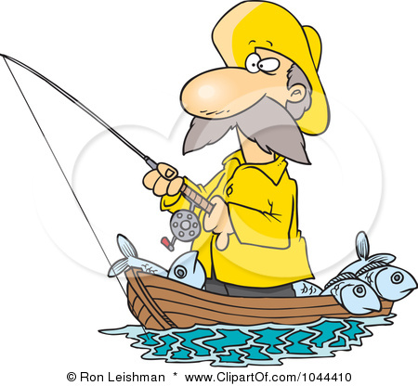
Making “Grabbing” Opening Lines in Writing
Notes

What are Grabbers?

Grabbers should make the reader feel:
- curiosity
- humor
- wonder
- sympathy
- anger
- sorrow
- fear
- mystery
These feelings cause the reader to want to know what happens next. They get hooked on your story! There are many types of grabbers

How to write a good grabber:

1. Dialogue
- Have a character say something. “Why are you eating a tarantula?” my little sister asked.

2. Mystery Statement
- I was eleven when I found the key that would change my life.

3. Introduce a place
- The city was bursting full of people on the day I lost my first tooth.

4. Shocking Statement
- I’ll never forget the day my tongue turned purple and green.

5. Humorous Statement
- I didn’t mean to drive my teacher crazy. It just happened that way.

6. Question to the reader
- Don’t you think every boy deserves to have a dog of his own?

7. Action
- I screamed and twisted away from the man.

