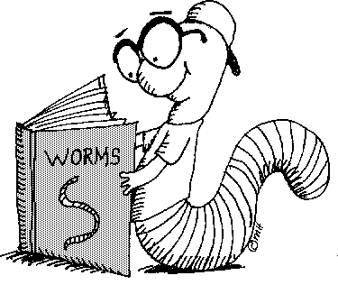
Language Arts 7th Grade
Ms. Nielsen
2012-2013

Course Description
Seventh grade Language Arts offers an in-depth and challenging study of writing, reading, research, grammar, spelling, and related concepts. Each quarter includes a combination of these elements.

- Writing instruction focuses on the 6 traits of writing, making personal connections, and basic skills in evaluation of writing. Students will need a separate notebook for this class to be used as a journal.
- Reading instruction focuses on both fiction and non-fiction texts. Students will be required to read 400 pages per quarter outside regular class time. This will be documented on the Reading Log.
- Research instruction focuses on gathering quality information to answer questions, formatting and sharing the relevant information.
- Grammar will focus on subject-verb agreement and verb tense.
- There will be a spelling list given to the students each Monday and a quiz on these words each Friday. The weekly list will be available on the class website.

These areas of study are aimed toward preparing students for the CRT state exams that will be given in May.

Materials for Language Arts
Each day, students will need to bring a pencil, paper, a reading book, and a notebook (to be used solely for Language Arts). I encourage parents to invest in a flash drive for their students. It is helpful for them to have a copy of work we do in the computer lab, and will likely be used in upper grades as well.

Major Writing Assignments
1st Quarter: Personal Narrative
2nd Quarter: Persuasive Writing
3rd Quarter: Research Paper
4th Quarter: Creative Writing (if scheduling allows)

Literature
Book Reports (1 per quarter)
Freak the Mighty by Rodman Philbrick
Touching Spirit Bear by Ben Mikaelsen
And Then There Were None by Agatha Christie

All units, assignments, and important calendar dates will be posted on the course website:
http://msnielsenlangarts.weebly.com

