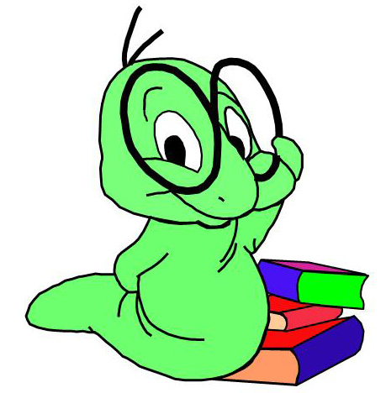
Creative Project Options

Choose one of the following three options.

Setting Map
Students must story map

Requirements:
- Create a map of the setting of your book
- Choose 5 different locations on the map and summarize (at least 2 sentences) what happened in each location (write this on your map)
- Map needs to be original and unique showing your own ideas
- Must be colored

Newspaper Article
Create a newspaper article about a major event that happened in your story.

Requirements:
- Format article to look like a newspaper column
- Include a picture with a caption that describes the event
- Article must be at least ½ page typed
- Article must include specific information about the major event in the story

Plot Diagram
Create a plot diagram of your novel

Requirements:
- Draw a plot diagram—must look nice!
- On the diagram include the beginning, 4 rising action events, the climax, 2 falling action events and the conclusion
- Diagram must be original and unique, showing your own ideas.
- Write a one paragraph (at least 5 sentences) review of the book, telling why you liked or disliked it.

