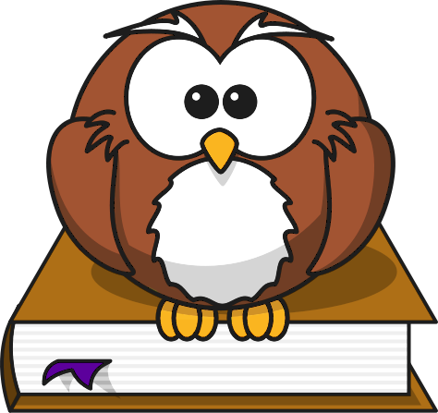
Creative Project Options

Choose one of the following three options.

Book cover
Students must create a book cover for their novel

Requirements:
- Differs from original book cover
- Needs to be on 8 by 11 paper, folded in half
- Write your own summary of the plot on the back of book cover (MUST be typed)
- Cover should be original and unique showing your own ideas
  - Can be hand-drawn or printed pictures can be glued on

Cereal Box
Create a cereal box with information and activities inspired by your novel.

Requirements:
- Nutritional information would go, include vital information for your man character
- Design a front panel for you novel using original ideas
- Activity on the back promoting your novel
- Also include three quotes and one extra character description (not included on your nutritional information sheet.)

Crossword Puzzles
Create a crossword puzzle with clues from the novel.

Requirements:
- Include 25 clues and an answer key
- You may create your crossword at the following website http://www.crosswordpuzzlegames.com/create.html
- Include clues about character names, places, key details from the novel.

