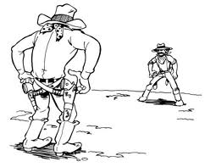
3rd Quarter Book Project

DUE MARCH 14th

Book vs. Film Showdown

This quarter’s book project will be an argumentative writing paper. You will need to choose a book that has been made into a movie (remember, this needs to be a book that you have not read before).
After you finish reading the book, watch the film version. Decide which version—the book or the film—is better (in your opinion). Write a persuasive paper that urges the reader to agree with you.

This needs to be 6 paragraphs, typed, and double-spaced. Follow this format:

Paragraph 1: Intro & Claim (i.e. The book is better than the film because…)
Paragraph 2: Reason #1
Paragraph 3: Reason #2
Paragraph 4: Reason #3
Paragraph 5: (Counter Argument)
Paragraph 6: Conclusion (Restate your claim and end strongly!)

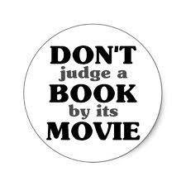

Some suggestions of books that have been made into films (there are many more out there!) Talk to your English Teacher if you don’t know what book to read

Harry Potter Twilight Percy Jackson
The Hunger Games The Lord of the Rings Marley & Me
The Golden Compass Coraline Eragon
Holes A Series of Unfortunate Events Inkheart
The Princess Diaries Alice in Wonderland Because of Winn-Dixie
War Horse Bridge to Terabithia Cirque du Freak
Ella Enchanted Diary of a Wimpy Kid How to Train Your Dragon
Freak the Mighty The Spiderwick Chronicles Tuck Everlasting
White Fang Where the Red Fern Grows A Walk to Remember
The Help The Invention of Hugo Cabret I am Number Four
The City of Ember The Guardians of Ga’Hoole The Tale of Despereaux
Hoot The Chronicles of Narnia Charlie and the Chocolate Factory

