Name:______________________ Date:__________________ Period:________________

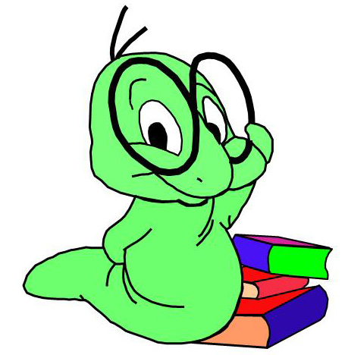
7th Grade Book Project Quarter 2
Due on Jan. 4

Students will be required to complete two portions for their book project. These portions are made up of a written portion and a creative portion.

The written portion will make up 75% of the grade and the creative portion will make up 25% of the grade. Following is a description of what will be required for each portion of the project.

Written portion
The written portion will contain a handout in which students will score the book on word choice according to the 6 traits rubric and defend their score of the novel with four examples from the book.

The written portion will be graded according to the rubric given.

Creative Portion
Students will choose one the following three options to complete

- Setting Map
- Newspaper Article
- Plot Diagram

The creative portion will be graded according to the description on the back of this paper. If the requirements are met, full points will be awarded.

